**SUMMER MASS SCHEDULE** **1st/2nd July to 9th/10th September inclusive**

[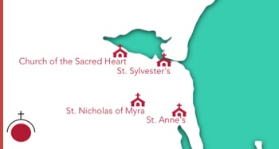](http://www.google.ie/url?sa=i&rct=j&q=&esrc=s&source=images&cd=&cad=rja&uact=8&ved=0ahUKEwj2xOTAxbTPAhUkI8AKHRDtCogQjRwIBw&url=http%3A%2F%2Fwww.yellowwallsparish.ie%2F&psig=AFQjCNHHVz-YP6gGIbMKN56LuETjMmUAQA&ust=1475237062490427)**Parish Partnership of Malahide, Portmarnock, Yellow Walls and Kinsealy**

CHURCH OF THE SACRED HEART, YELLOW WALLS:

Weekends: Saturday at 6.00pm – (Vigil Mass for Sunday)

Sunday Mass at 11.30am (One Mass only)

Weekdays: (Mon, Tues, Thurs, Fri) - Mass at 9.30am

(Wednesday) – Service of the Word at 9.30am

ST. SYLVESTER’S CHURCH, MALAHIDE VILLAGE

Weekends: Saturday morning Mass at 10.00am

Sunday Masses at 08.30am, 10.00am, 11.30 am

Weekdays: (Mon, Tues, Wed, Fri) - Mass at 10.00am

(Thursday) – Service of the Word at 10.00am

ST. ANNE’S CHURCH PORTMARNOCK

Weekends: Saturday at 6.30pm – (Vigil Mass for Sunday)

Sunday Mass at 12.00 noon (One Mass only)

Weekdays: (Mon, Wed, Thu, Fri) - Mass at 10.00am

ST. NICHOLAS OF MYRA CHURCH, KINSEALY

Weekends: Sunday Mass at 11.00am. (One Mass only)

Weekdays: Wed & Fri Mass at 10.00 am.